**Part 2 – High-Boost Filtering**

function sharp_image = sharpen(image, alpha)

%{

sharpened image equation: f_s(x,y) = f(x,y) + αg(x,y)

f(x,y) = original image

α = user-specified scaling constant

g(x,y) = high frequency content (found using the Laplacian filter)

%}

% laplacian filter to obtain the high frequency data from the image

laplacian_filter = [0 -0.25 0; -0.25 1 -0.25; 0 -0.25 0];

% filter the original image with α*g(x,y)

image_high_freq = filter2(alpha * laplacian_filter, image);

% sum the high frequency component with the original image to obtain the

% sharpened image

sharp_image = uint8(double(image) + double(image_high_freq));

end

*moon.tiff*

After trying several different values for α, the value that appears to work best is when α is equal to 5 (shown above). As you increase α after 5, the image appears to become more grainy and pixelated.

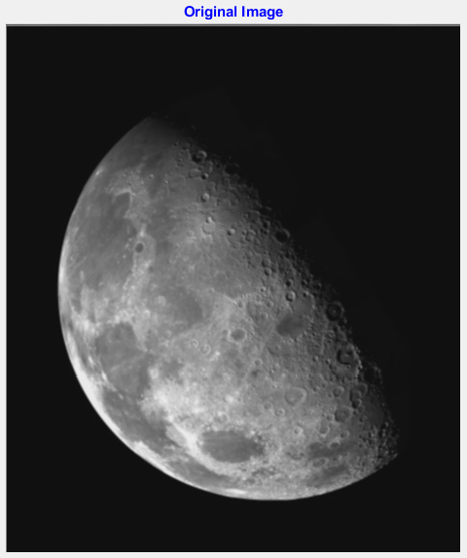

Figure 1: Original moon.tiff image

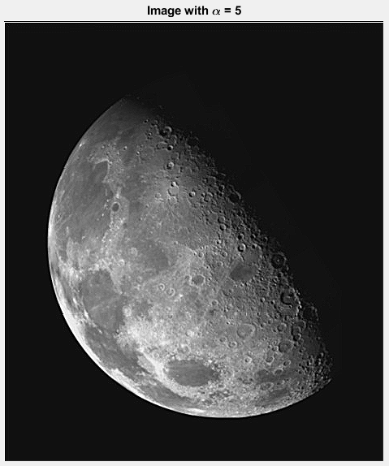

Figure 2: Sharpened image (α =5)

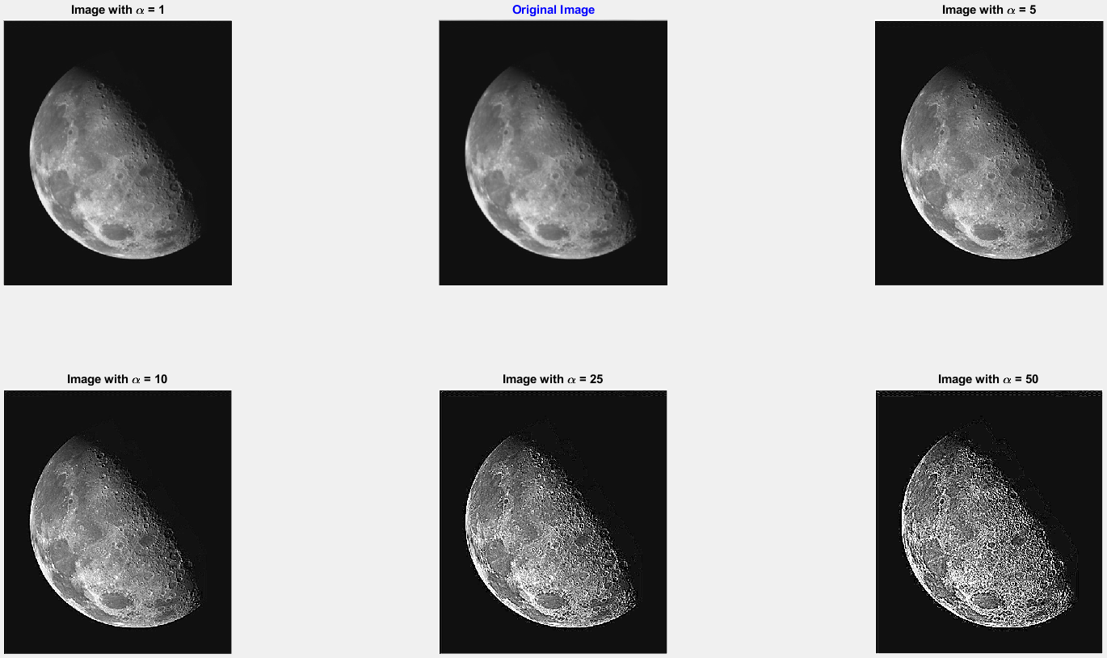

Figure 3: moon.tiff - Original image and α = 1, 5, 10, 25, 50

*outoffocus.tiff*

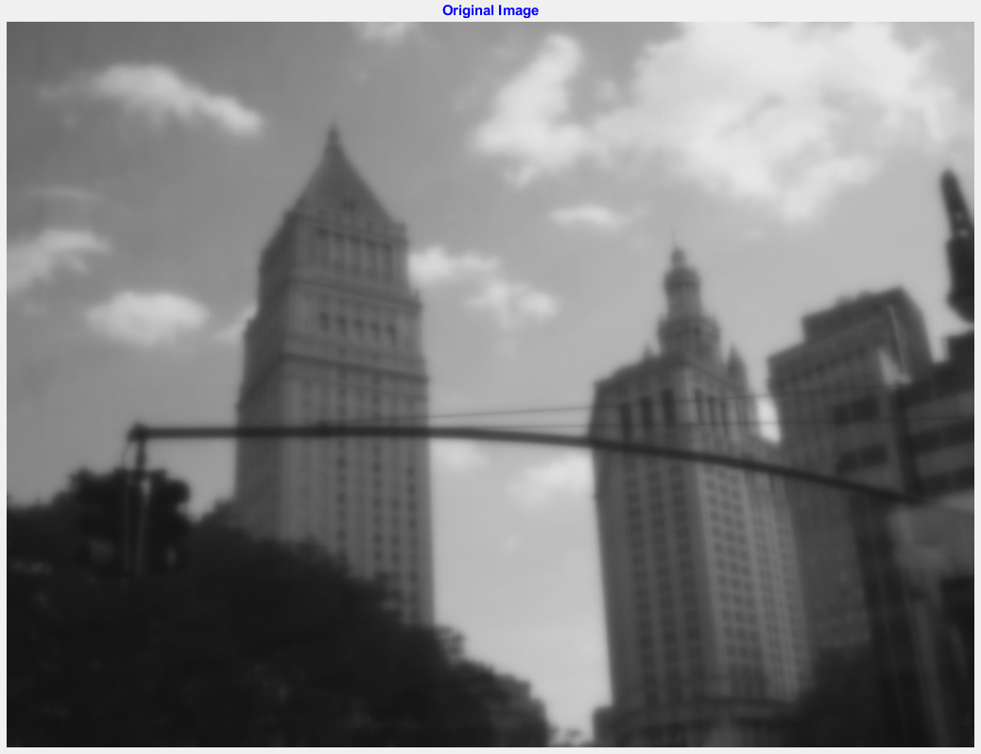

Figure 4: Original outoffocus.tiff image

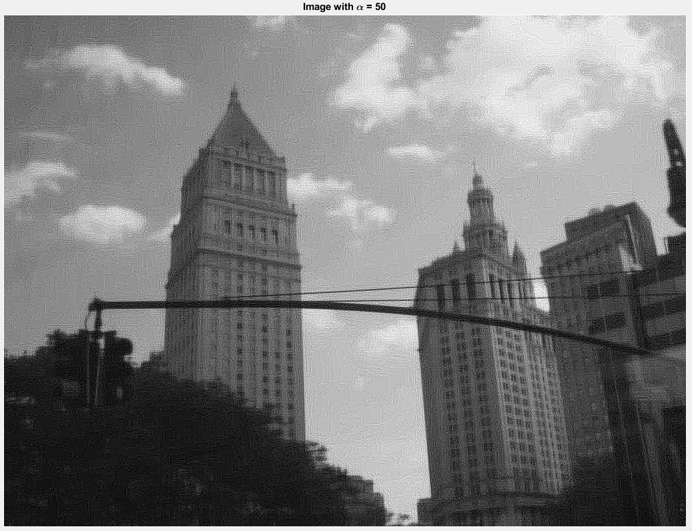

Figure 5: Sharpened image (α = 50)

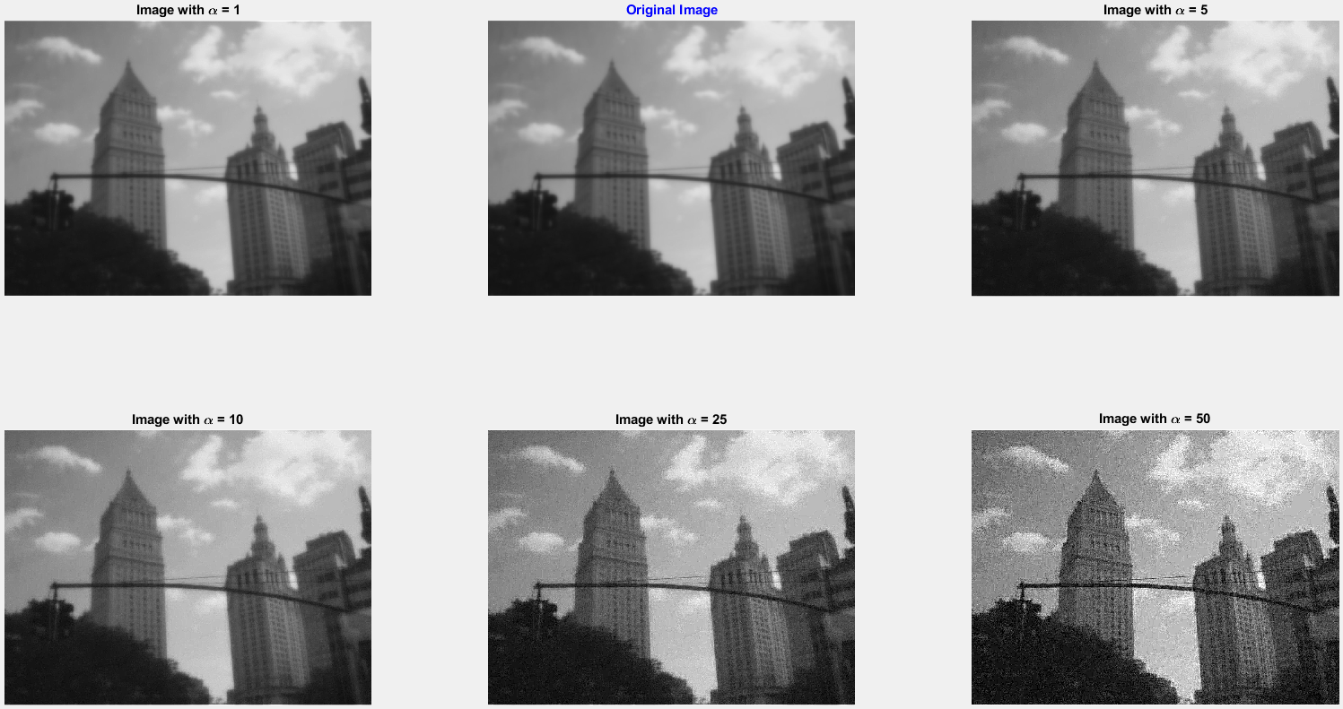

Figure 6: outoffocus.tiff - Original image and α = 1, 5, 10, 25, 50

It does not appear that you can recover the original in-focus image. You may appear to recover the image if you sharpen it and make the image smaller but the eyes are correcting for the blurriness.

There are unintended artifacts, such as contouring, that show up as you increase the value of α (shown below).

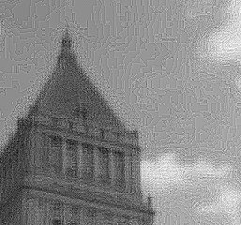

Figure 7: α = 50

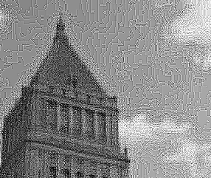

Figure 8: α = 100